MINISTRY OF EDUCATION  IMAM ABDULRAHMAN BIN  FAISAL UNIVERSITY  COLLEGE OF COMPUTER SCIENCE  & INFORMATION TECHNOLOGY | وزارة التعليم  جامعة الإمام  عبدالرحمن بن فيصل  كلية علوم الحاسب  وتقنية المعلومات


CIS 315 - Project proposal
Term 1 – 2024/2025
Project proposal form


Title of the project: Design and Configuration of a
Small Business Network for a Multi-floor Organization

Section Number: 2
Group #7
Instructor: Mrs. Fatimah Alhassan
Group members:

Name | ID
Lojain Alghareeb
Fatima Alhanfoosh
Yasmin Alshabaan
Farah Aljokam

Introduction:

In today’s fast-paced business environment, ensuring seamless communication and resource sharing is crucial for the success of any organization. This project aims to design and configure a Local Area Network (LAN) for a small organization that spans multiple floors with different departments. The network will be designed using Cisco Packet Tracer and will be scalable, allowing for future expansions as the organization grows. The goal is to ensure reliable connectivity, efficient resource sharing, and secure communication between the departments on different floors while maintaining easy management and accessibility.



Project initial topology draft:

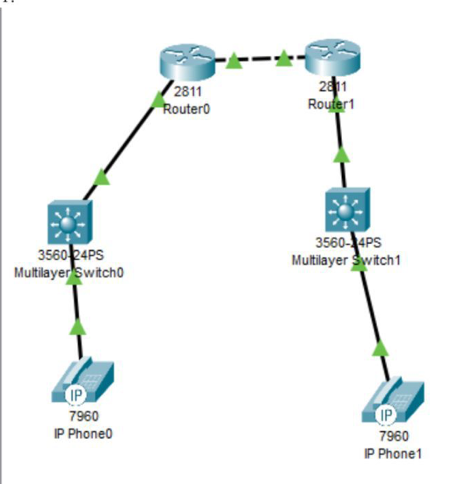

Components:
- 4 Cisco routers ( cisco 2811 routers )
- 11 PC
- 3 servers
- 5 switches ( 3 2960 switch and 2 ML SW )
- 4 laptops
- 2 printers
- 3Access points

describing the implementation of the topology :

The network topology was implemented by designing and configuring a Local Area Network (LAN) for a small, multi-floor organization using Cisco Packet Tracer. The topology includes devices like routers, switches, wireless access points, and PCs distributed across floors. VLANs were created to separate departments, with inter-VLAN routing enabled via routers. IP addresses were assigned to devices according to the addressing table, ensuring efficient communication and resource sharing. VOIP was configured to facilitate communication between staff. The configuration process included setting up hardware modules (HWIC-2T) for the routers, assigning IPs and subnet masks, and connecting the routers, switches, and access points to establish reliable wired and wireless connections. The topology design ensures scalability, security, and effective traffic management to meet current and future organizational needs

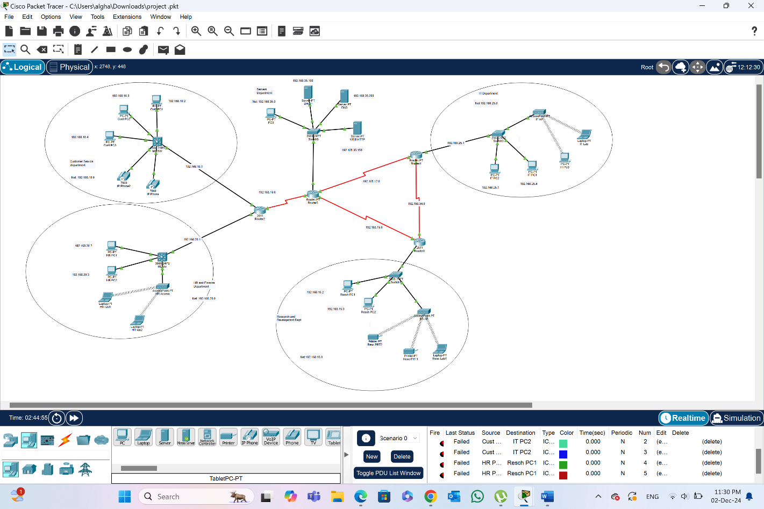

Adressing table

Device | interface | IP address | Subnet mask | Default Gateaway
Router0 | FastEthernet0/0  Serial 0/1/0  Serial 0/1/1 | 192.168.16.1  192.168.14.1  192.168.34.1 | 255.255.255.0  255.255.255.0  255.255.255.0 | N/A
Router1 | FastEthernet0/0  Serial 2/0  Serial 3/0`  Serial 8/0 | 192.168.25.1  192.168.12.2  192.168.34.2  192.168.105.1 | 255.255.255.0  255.255.255.0  255.255.255.0  255.255.255.0 | N/A
Router2 | FastEthernet0/0  FastEthernet0/1  Serial 0/1/0 | 192.168.10.1  192.168.20.1  192.168.16.2 | 255.255.255.0  255.255.255.0  255.255.255.0 | N/A
Router3 | FastEthernet0/0  Serial 2/0  Serial 3/0  Serial 8/0 | 192.168.35.254  192.168.14.2  192.168.12.1  192.168.16.1 | 255.255.255.0  255.255.255.0  255.255.255.0  255.255.255.0 | N/A
Server DHCP | FastEthernet 0 | 192.168.35.100 | 255.255.255.0 | 192.168.35.254
Server DNS | FastEthernet 0 | 192.168.35.200 | 255.255.255.0 | 192.168.35.254
Server WEB HTTP | FastEthernet 0 | 192.168.35.150 | 255.255.255.0 | 192.168.35.254
PC 9 | FastEthernet0 | 192.168.35.1 | 255.255.255.0 | 192.168.35.254
IT PC 1 | FastEthernet 0 | 192.168.25.4 | 255.255.255.0 | 192.168.25.1
IT PC 2 | FastEthernet 0 | 192.168.25.2 | 255.255.255.0 | 192.168.25.254
IT PC 3 | Wireless 0 | 192.168.25.3 | 255.255.255.0 | 192.168.25.254
Cust PC 1 | FastEthernet 0 | 192.168.10.2 | 255.255.255.0 | 192.168.10.1
Cust PC 2 | FastEthernet 0 | 192.168.10.3 | 255.255.255.0 | 192.168.10.1
Cust PC 3 | FastEthernet 0 | 192.168.10.4 | 255.255.255.0 | N/A
HR PC 1 | FastEthernet 0 | 192.168.20.2 | 255.255.255.0 | 192.168.20.1
HR PC 2 | FastEthernet 0 | 192.168.20.3 | 255.255.255.0 | 192.168.20.1
Resch PC 1 | FastEthernet 0 | 192.168.15.2 | 255.255.255.0 | 192.168.15.1
Resch PC 2 | fastEthernet 0 | 192.168.15.3 | 255.255.255.0 | 192.168.15.1
IT lab | Wireless 0 | 169.254.213.94 | 255.255.0.0 | N/A
HR lab 1 | Wireless 0 | 169.254.187.204 | 255.255.0.0 | N/A
HR lab 2 | Wireless 0 | 169.254.21.204 | 255.255.0.0 | N/A
Resc lab 1 | Wireless 0 | 169.254.219.1 | 255.255.0.0 | N/A
Resc PRT 1 | Wireless 0 | 169.254.201.116 | 255.255.0.0 | N/A
Resc PRT 2 | Wireless 0 | 169.254.187.205 | 255.255.0.0 | N/A
IP phone | Vlan1 | 192.168.10.5 | 255.255.255.0 | 192.168.10.1
IP phone 2 | Vlan1 | 192.168.10.6 | 255.255.255.0 | 192.168.10.1

Configuration
Router configuration

1- First, we have to put ( HWIC-2T ) to the router in order to be able to connect them with a wire.
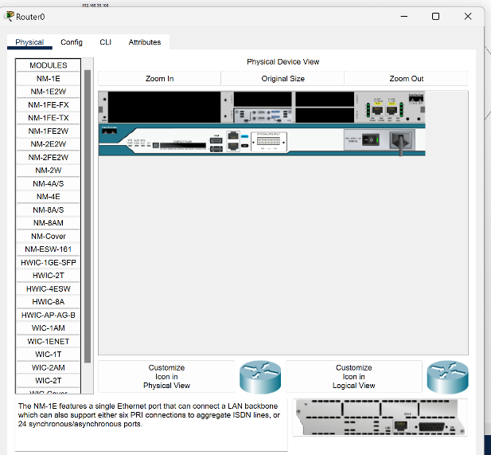

1-Seconed step is to configure the routers by assigning the IP address for each one, the subnet mask will appear automatically.

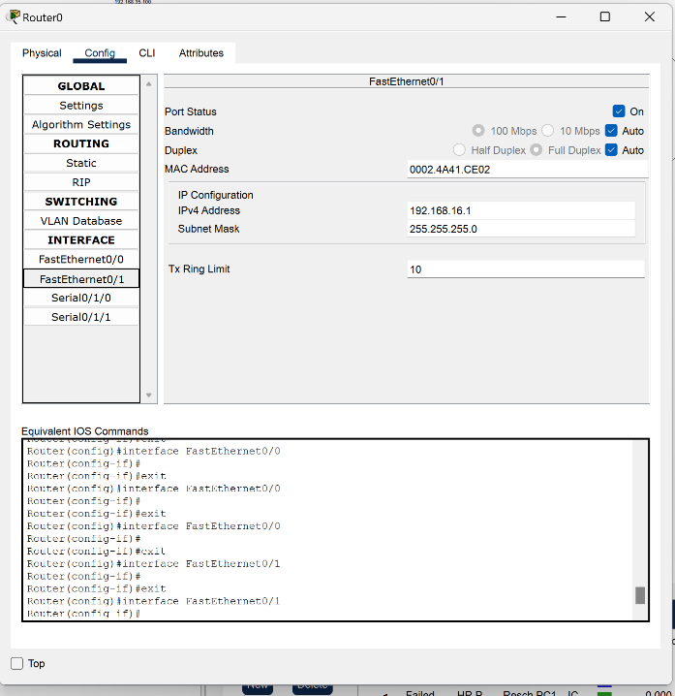

Connecting the routers together

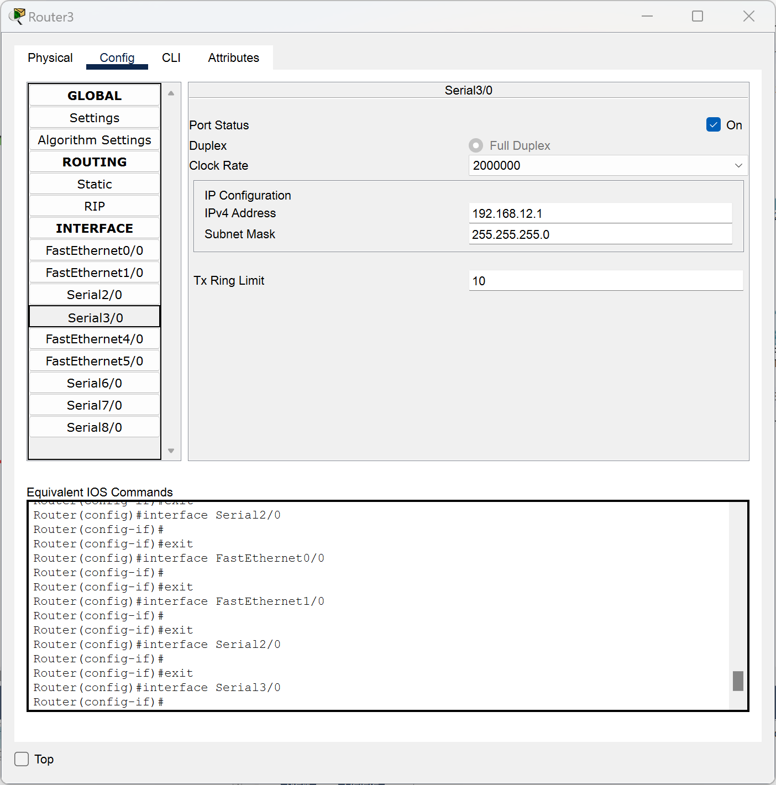
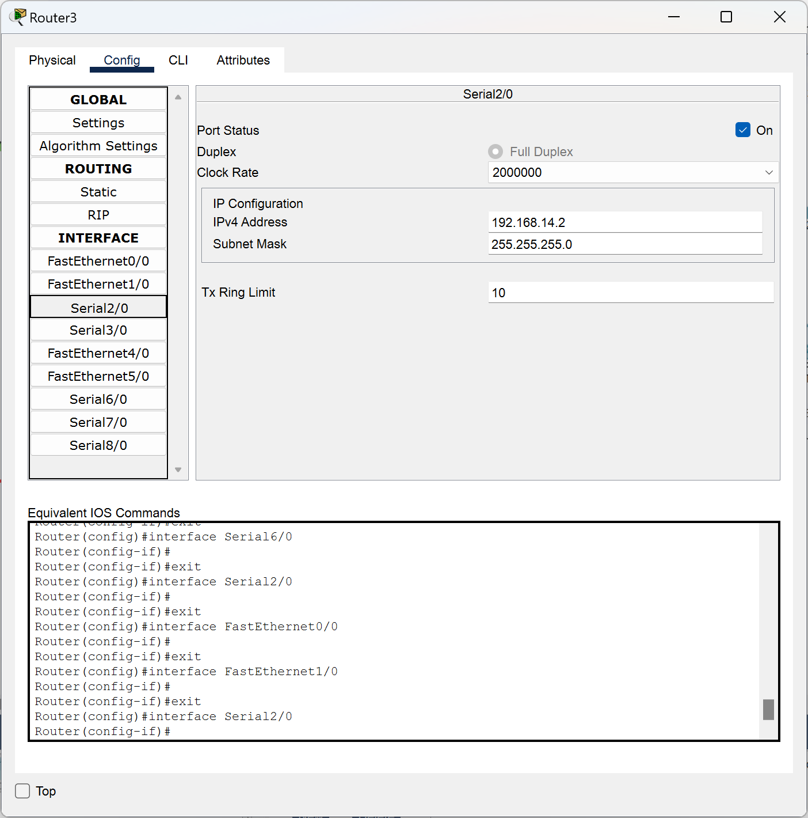

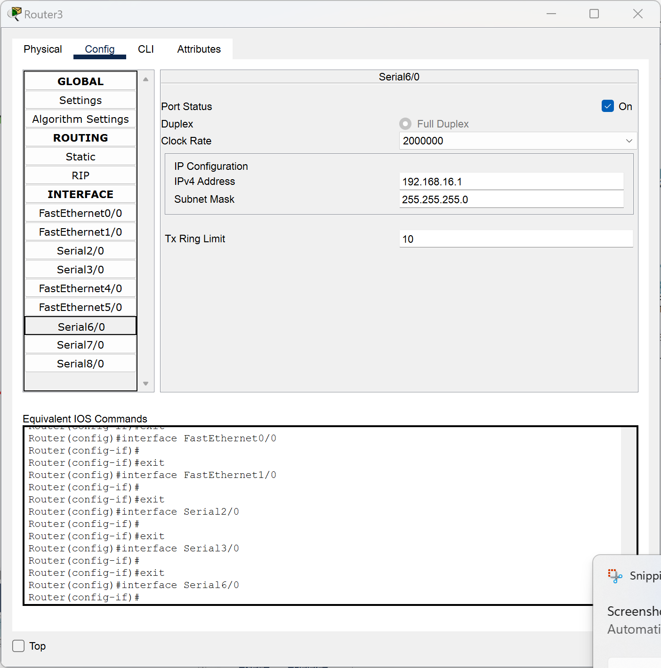

PC and server configuration

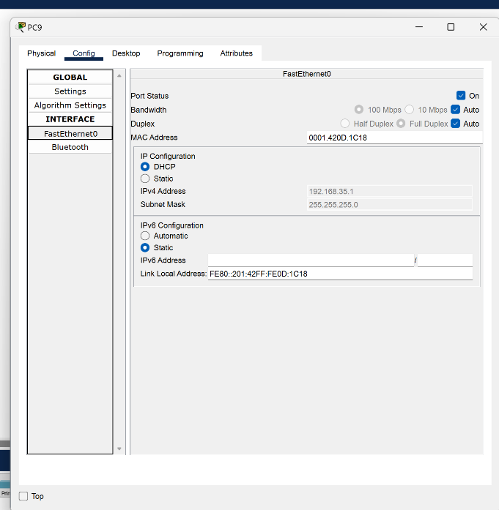

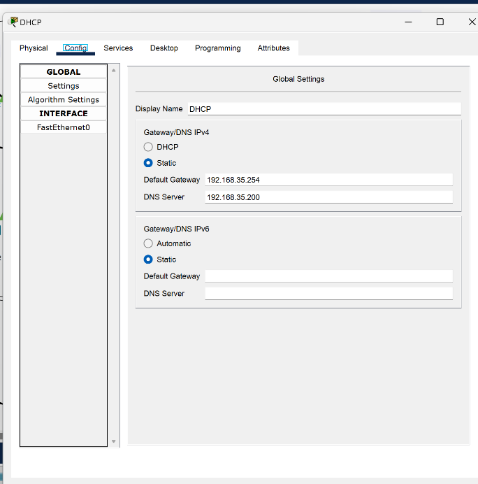
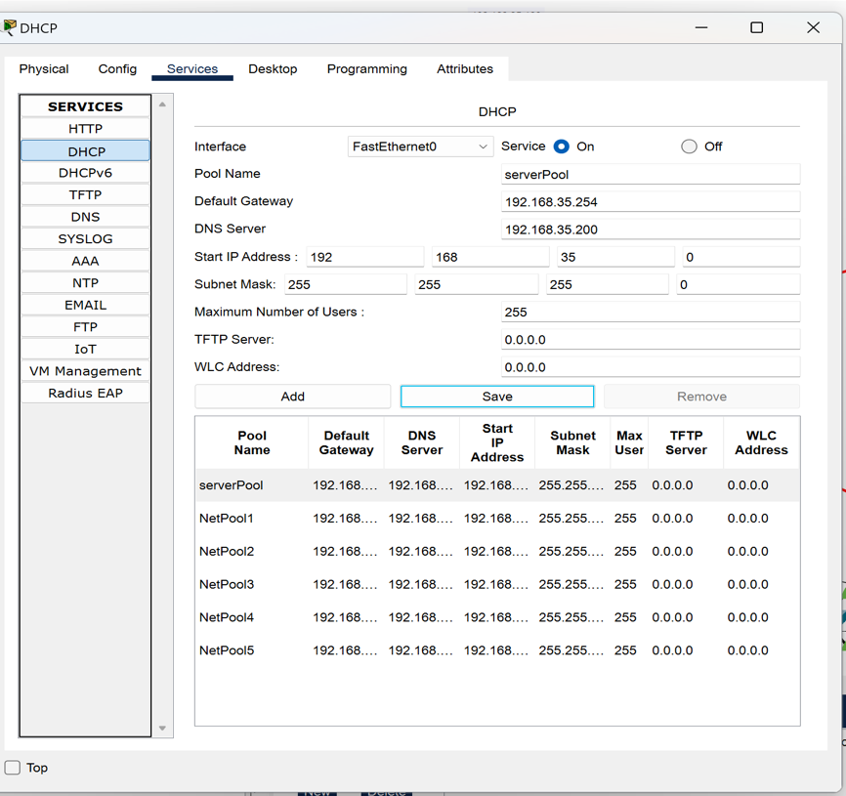
The server makes the assigning of IP addresses easier and faster for us, it creates a subnet and assigning the addresses by itself.

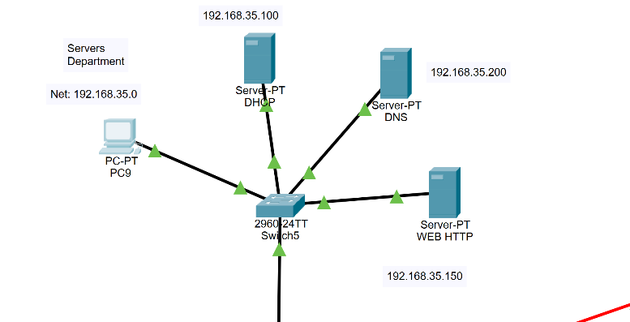

Customer service department
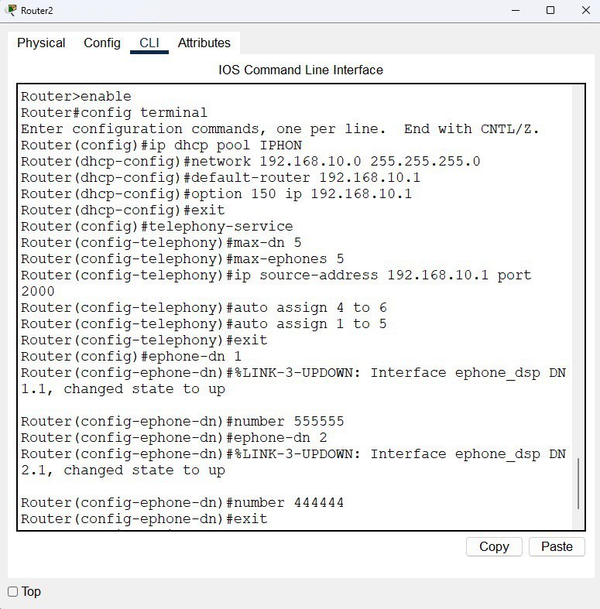

In the router we will assign IP address for the phone and the numbers .

VOIP Configuration

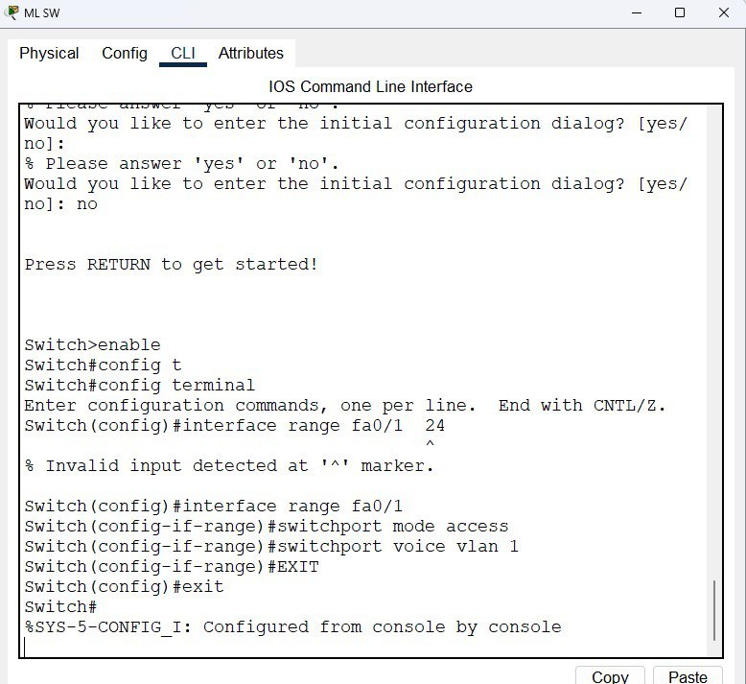
Switch VOIP Config

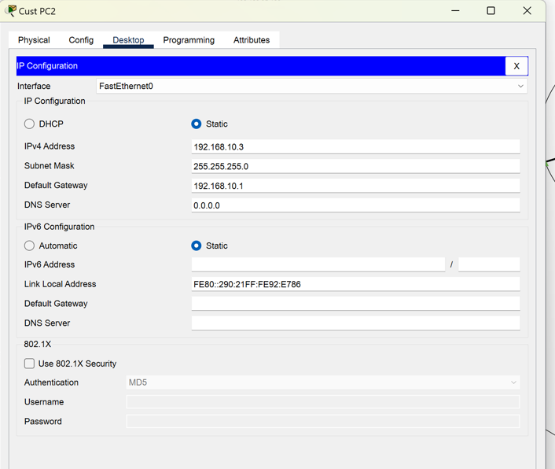

IP phones configure first we connect the VOIP power adapter then after we are done configuring the switch and router, the phones will work.

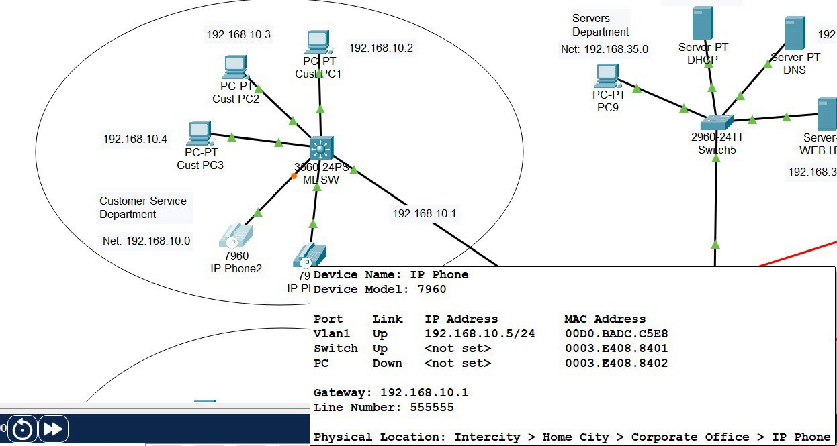

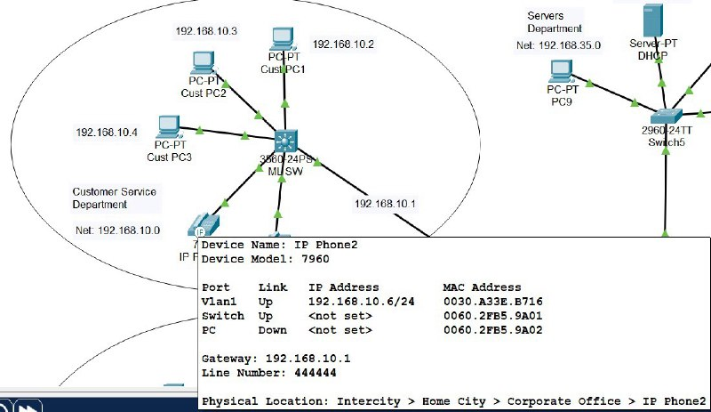
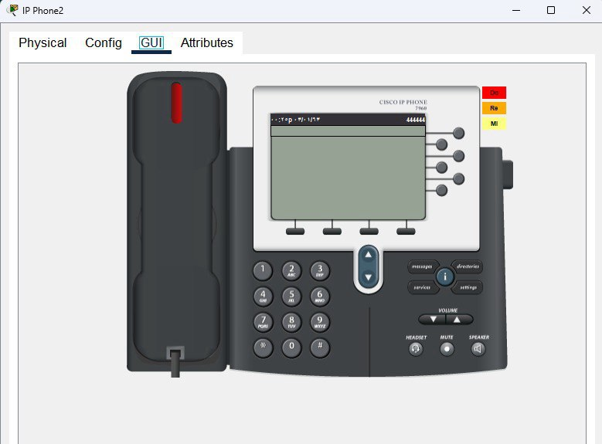

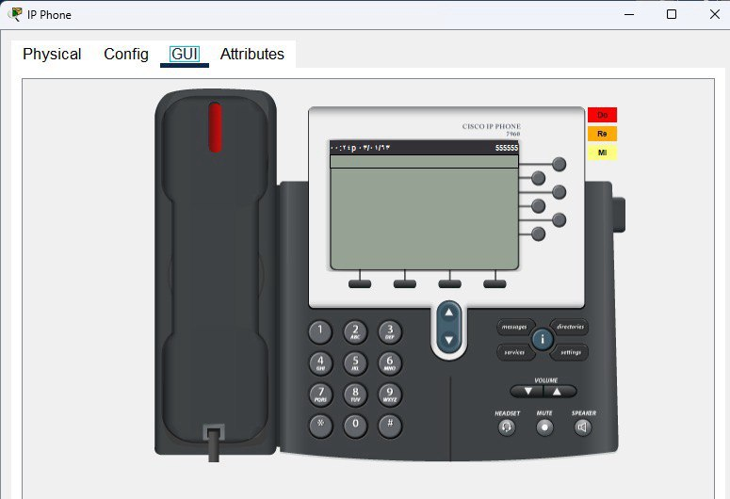

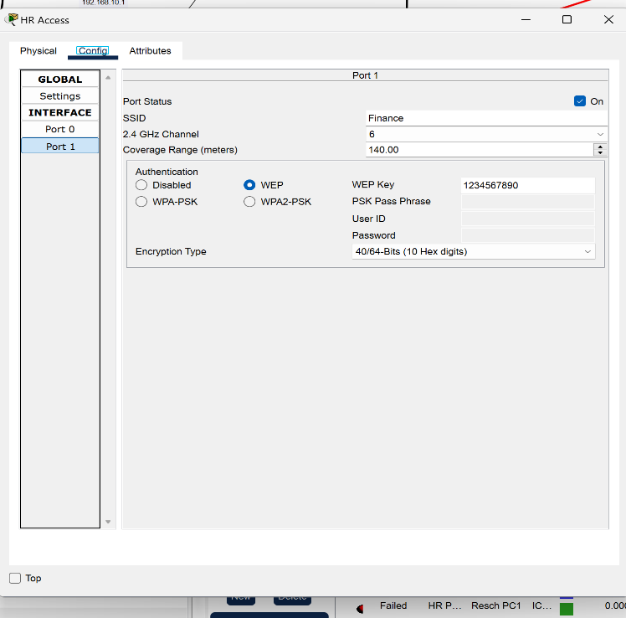
In the HR department
Connect with access point config

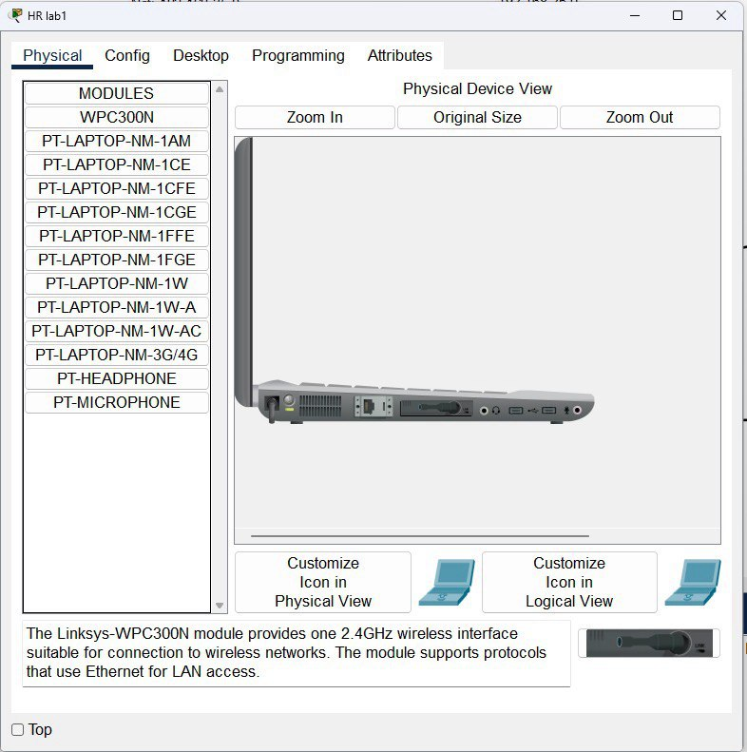

Laptop configuration
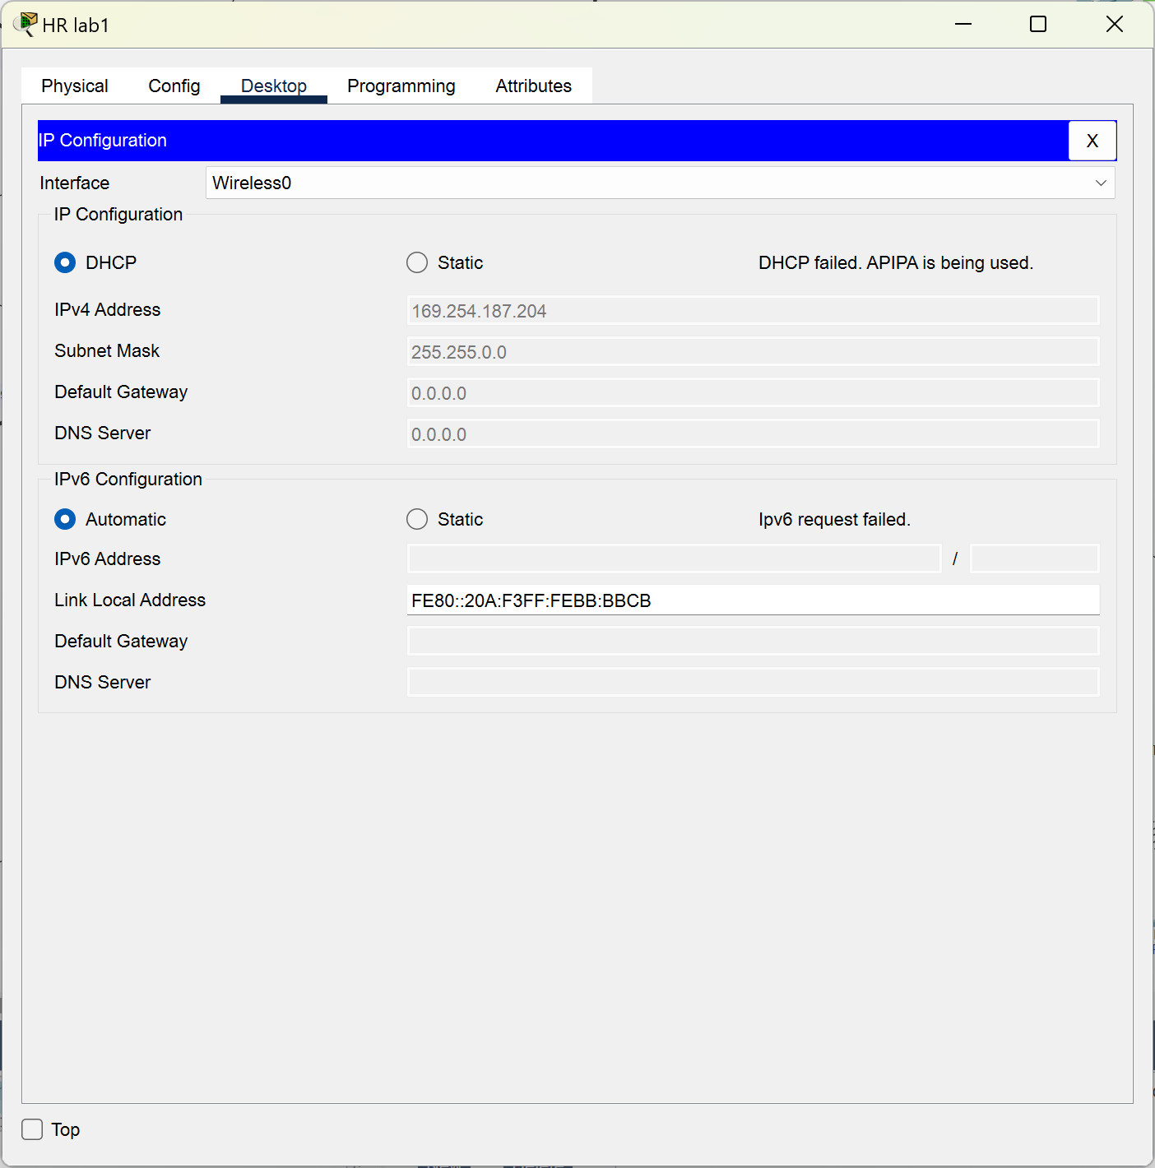
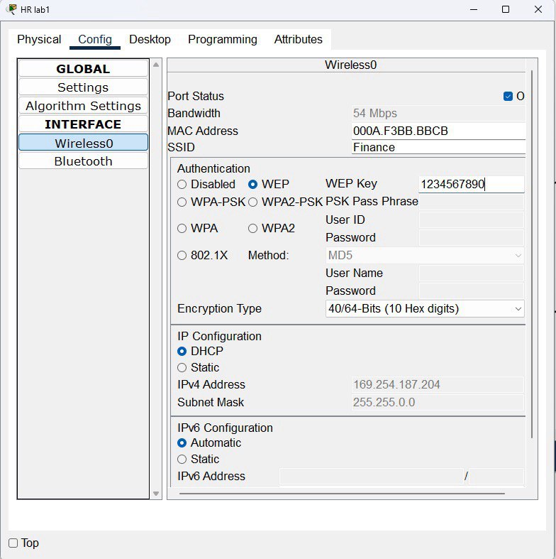

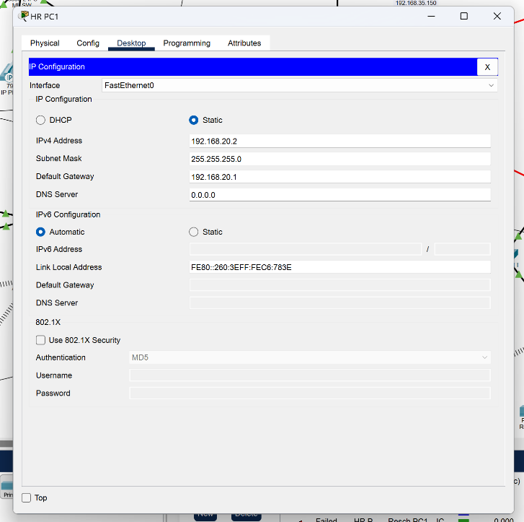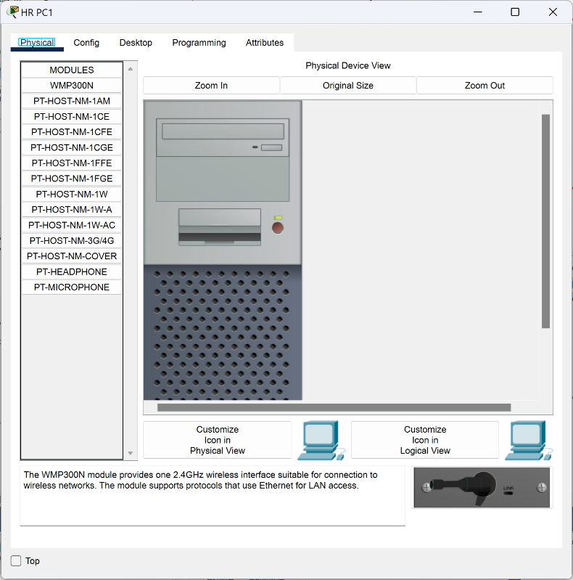

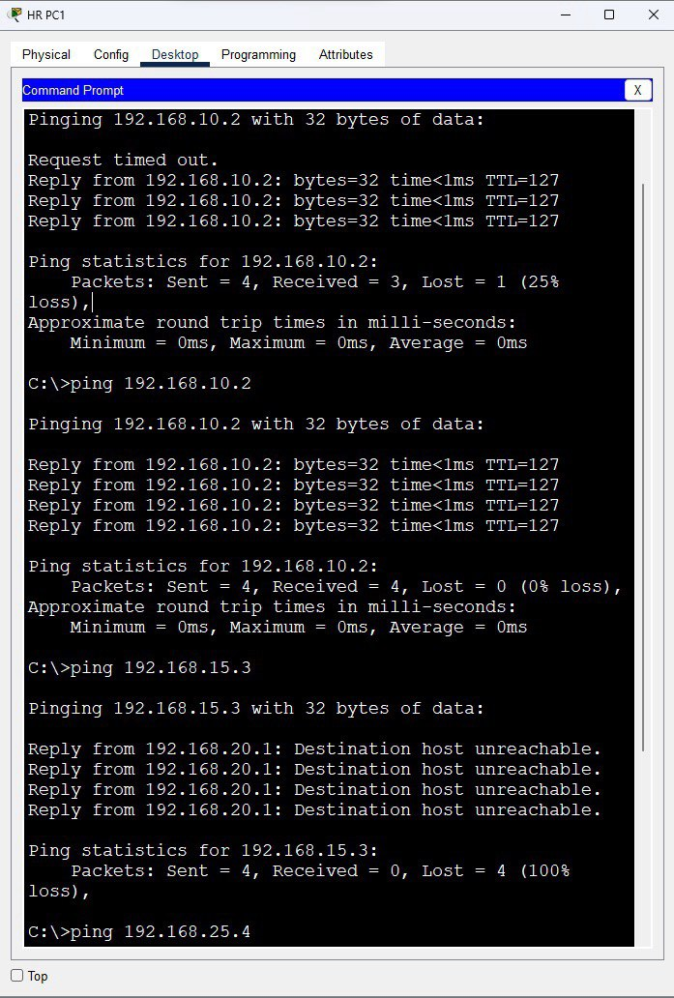

Printer configuration
We add WMP300N for connecting to the wireless networks. The module supports protocols that use ethernet for LAN access
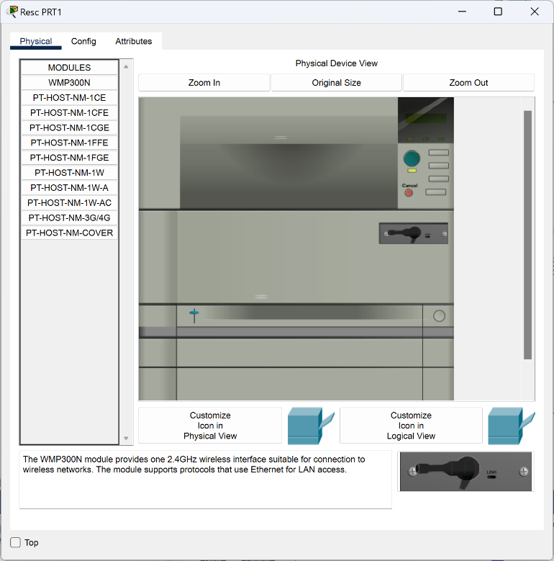

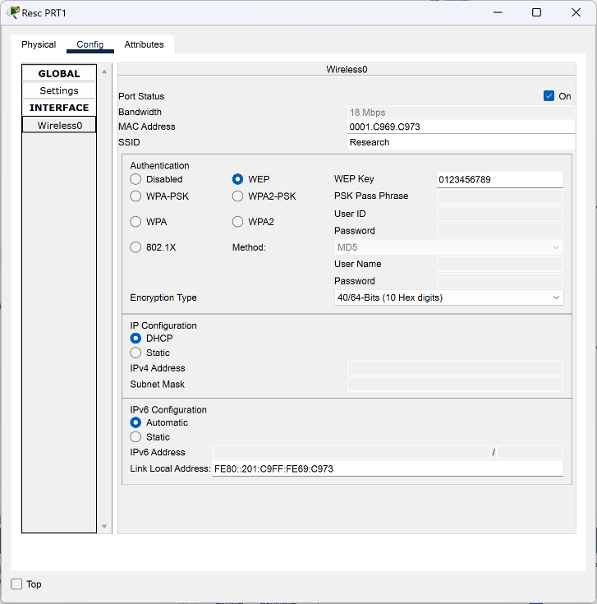

Choosing DHCP option and everything will appear to us

Access point
Assign SSID name and password then connecting the laptop and printers
We added this device to make a wireless connection
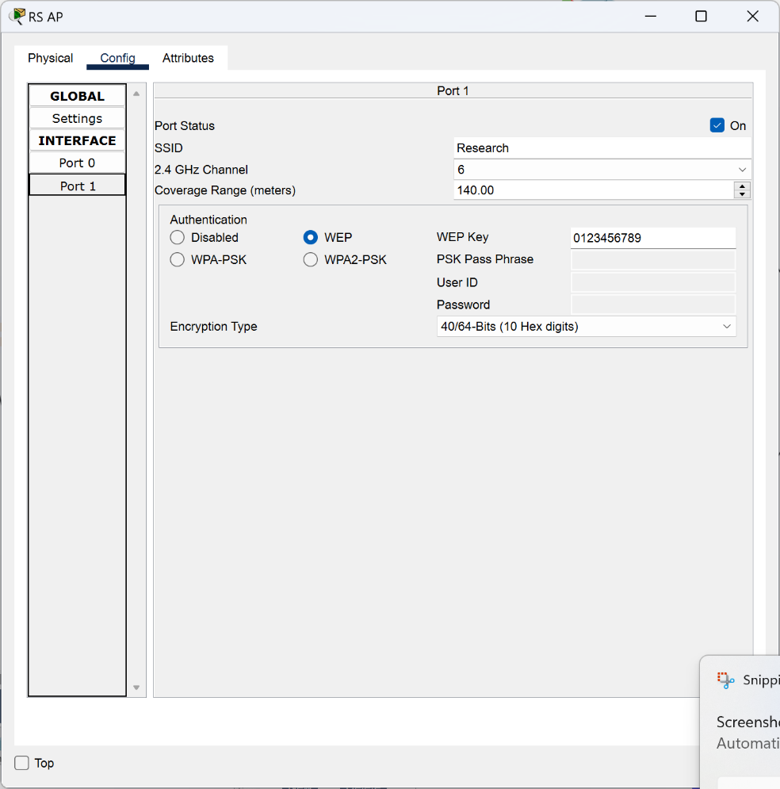

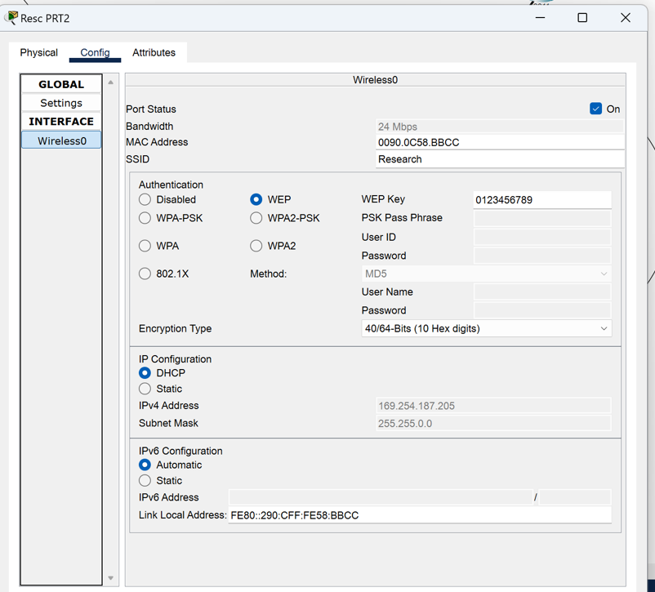

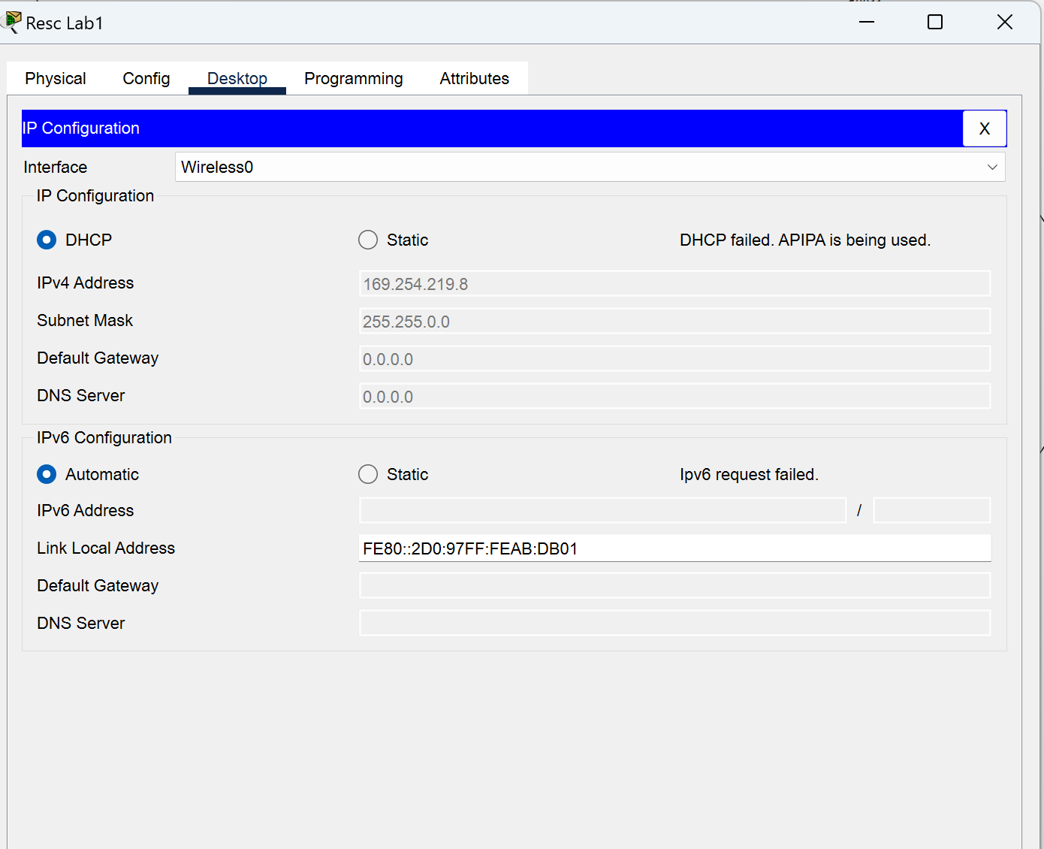

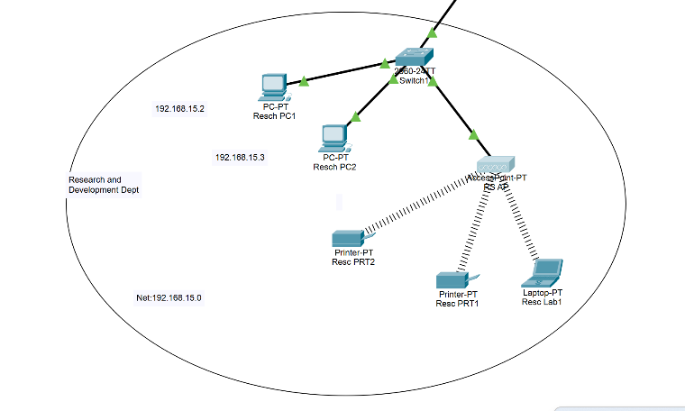

IT Department ,
Same way as we did before

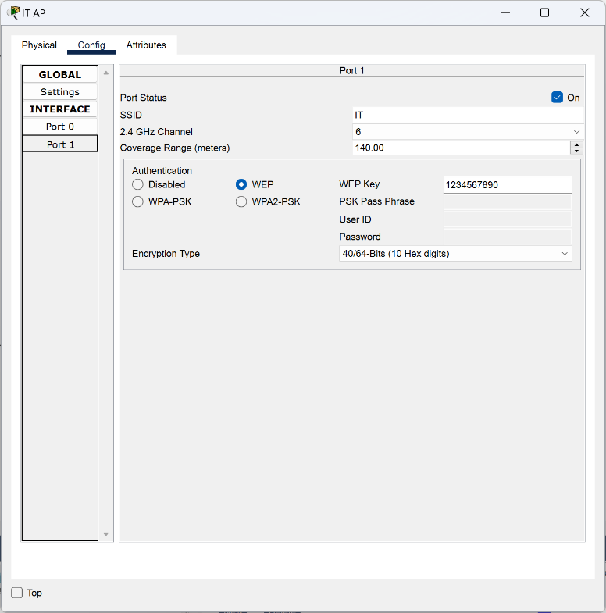
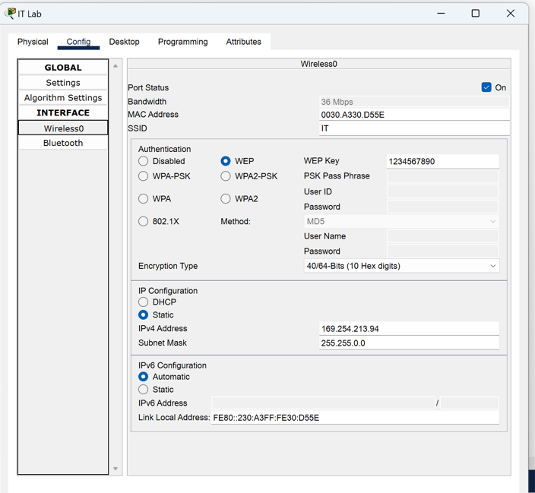

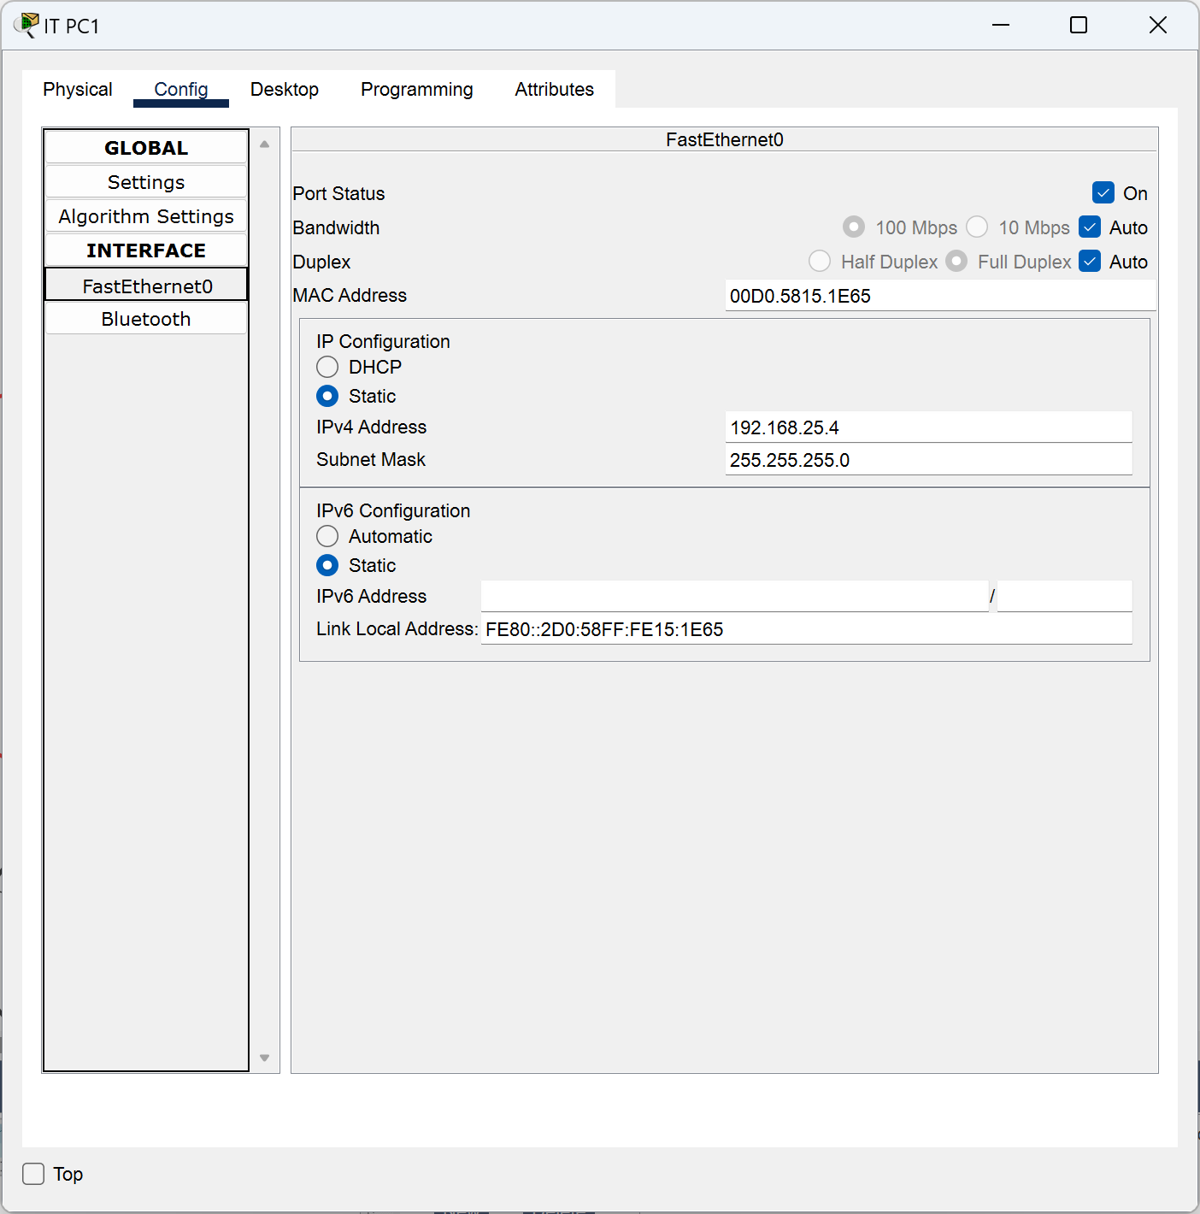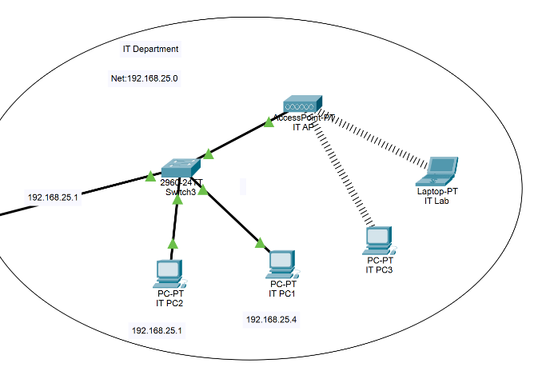

Ping:
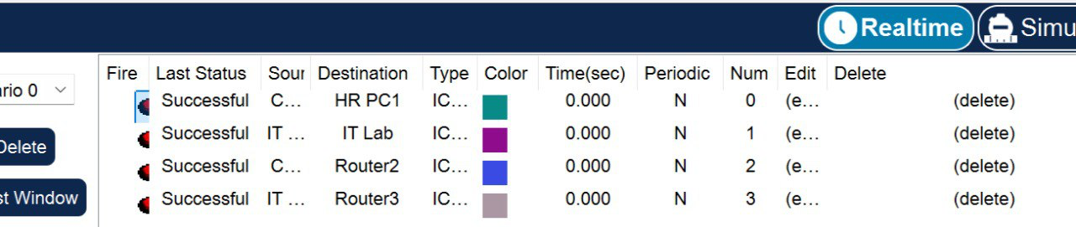
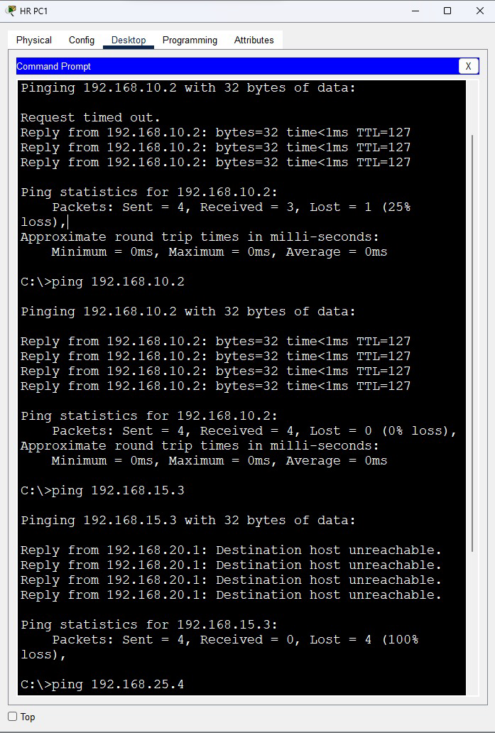

Conclusion:

In conclusion, the designed network topology provides a reliable, scalable, and secure infrastructure for the organization’s multi-floor setup. By utilizing routers for inter-VLAN communication, switches for efficient device connectivity, and access points for wireless coverage, the network ensures seamless interaction between departments. The inclusion of servers for DHCP, DNS, and web hosting simplifies resource management and supports daily operations. IP phones enhance communication through VOIP, while the careful allocation of IP addresses and VLANs ensures optimized traffic flow and security. This design not only meets the organization’s current needs but also allows for future expansion, demonstrating a well-structured and sustainable network solution.



